Tinder Mini

Version 1.0

Revision History

|  |  |  |  |
| --- | --- | --- | --- |
| **Date** | **Version** | **Description** | **Author** |
| 14/12/2022 | 1.0 | UI design for apps | Nguyen Hai Dang  Nguyen Van Hieu |
|  |  |  |  |
|  |  |  |  |
|  |  |  |  |

Table of Contents

1. Main Screen 4

2. Sign Up Screen - Email 5

3. Create Profile Screen 6

# Main Screen

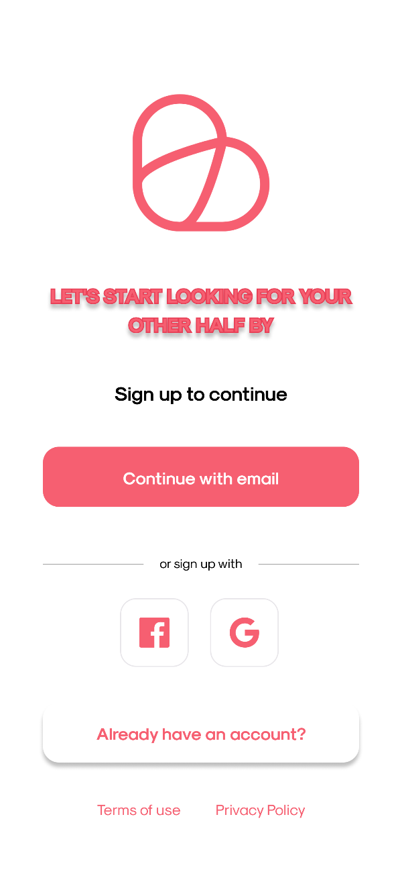

This is the first screen when a new user enters the application.

There are registration forms: via email, google, facebook.

If the user already has an account, the user can click on the button "Already have an account?".

# Sign Up Screen - Email

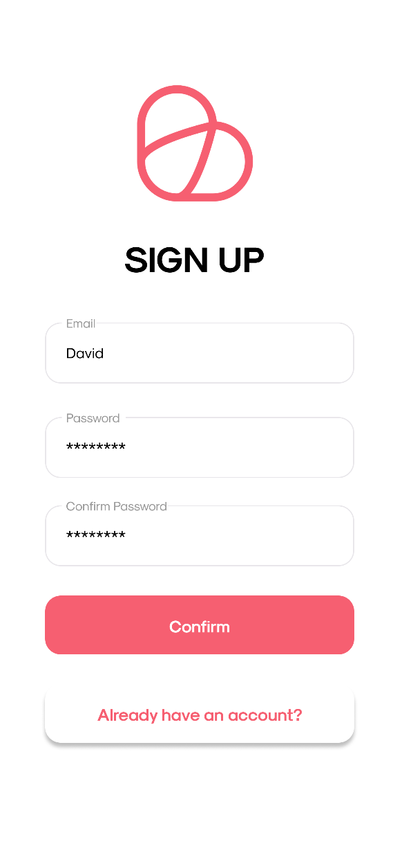

This is the email account registration screen.

There are data fields are: email, password, re-enter password. Users need to enter all 3 data fields correctly to be able to register an account.

If the user already has an account, the user can log in by clicking the button "Already have an account?".

# Create Profile Screen

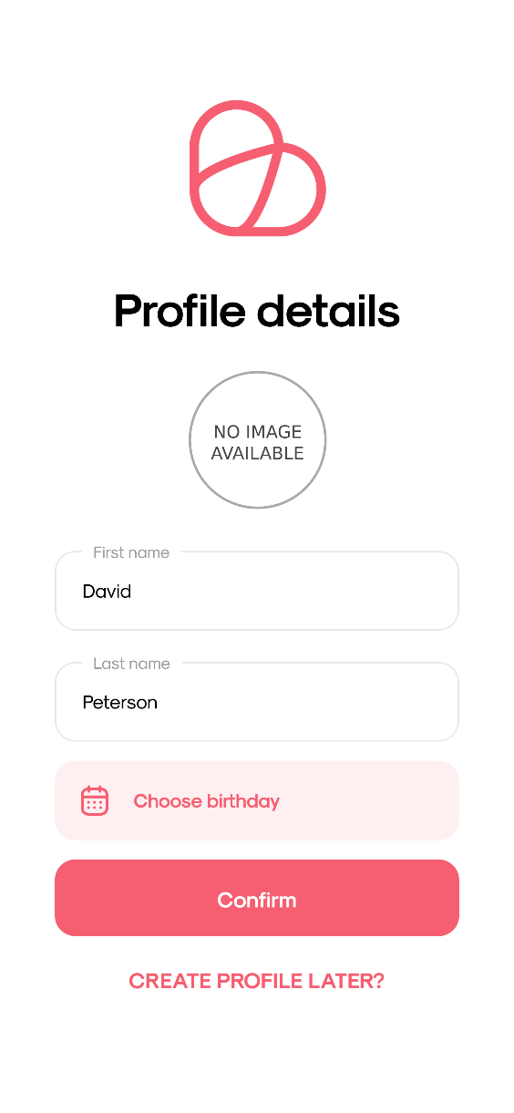

This is the screen when a user creates a profile right after registering an account.

The user will enter the information fields: last name, first name, date of birth (there will be a Date Picker screen for the user to choose a date). In addition, users can choose an avatar from their phone by clicking on the image with the word "No image available" or clicking on the avatar if they already have an avatar.

Then the user clicks the "Confirm" button to create a profile.

However, users can create profiles later by clicking "CREATE PROFILE LATER?".